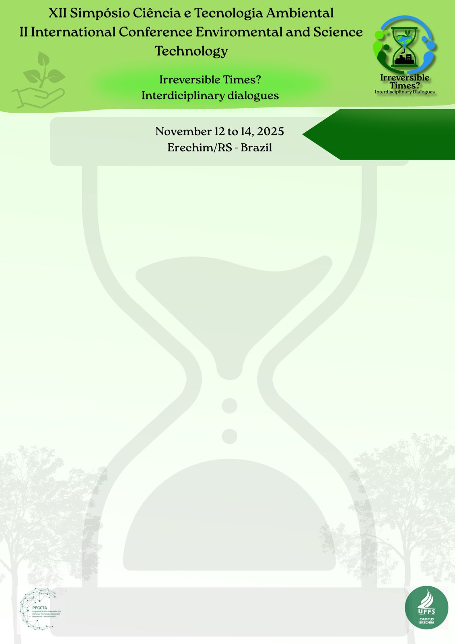

Insert category here:

PROJECT or WORK WITH RESULTS

**TITLE**

Author1*, Author2, Author3....

1 Academic title, institution, Campus, contact: xxxx@

2 Academic title, institution, Campus, scholarship holder (if applicable, inform the type of scholarship), contact: xxxx@

3 Academic title, institution, Campus, scholarship holder (if applicable, inform the type of scholarship), contact: xxxx@

**If the institution is the same, the number is repeated for each author, without the need to include a number for each one.**

The abstract in the **PROJECT** category must be written in Arial font, size 11, justified text and single spacing. The text must contain a single paragraph (running text without topics), without indentation of the first line, with single spacing and **must not exceed 300 words**, and must address: **introduction, objectives, methodology and expected results.** Citations, references, figures, charts and tables are not permitted.

The abstract in the category **PAPERS WITH RESULTS** must be written in Arial font, size 11, justified text and single spacing. The text must contain a single paragraph (running text without topics), without indentation of the first line, with single spacing and **must not exceed 300 words**, and must address: **introduction, objectives, methodology, results and discussion and final considerations**. Citations, references, figures, charts and tables are not permitted.

The abstract category will be indicated in the registration form, as well as in the location indicated in the abstract file. In the text, simply follow the instructions in this template and on the website.

**The formatting of the template must not be changed, such as margins, line spacing, etc.** In the keywords, there must be no repetition of words used in the title of the abstract.

The abstract in doc and the poster in jpg **must be submitted in the registration form**. **Attention: fill out correctly in the registration form (extremely important for issuing certificates, please pay attention to this information).**

**Keywords:** Word1, Word2, Word3. (3 to 5 words)

Maximum limit of **one page**

Send in **Doc** format.

**Important:**

✔ It is not necessary for all co-authors of the paper to register for the event, only the first author. However, it is necessary that the authors' complete data be sent on the form with the paper for issuing a certificate;

✔ There is no limit on the number of authors for the abstracts;

✔ THE AUTHOR'S PARTICIPATION DURING THE EVENT IS ESSENTIAL. The abstract will only be published in the Proceedings of the event if the corresponding author participates;

✔ The content of the abstract must be presented in general in POSTER format.